**Development Log**

**Week 1 - UI**

* Introduction to the module
* Research on old designs of items and how the newer versions compare to them
* Research on Apple Iphone and Steve Jobs
* Find two definitions which are User Experience & Human-Computer Interaction
* Creating a simple UI simulation by using MS Powerpoint

**Week 2**

* Tried experimenting with Photopea

**Week 3**

* Went through the history of graphic design
* Went through the colour theory
* Trying out different colour harmonies consisting of up to 5 different colours in palette.

Example:

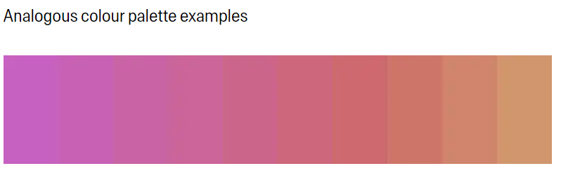

**Week 4**

Completed Ergonomics Course:

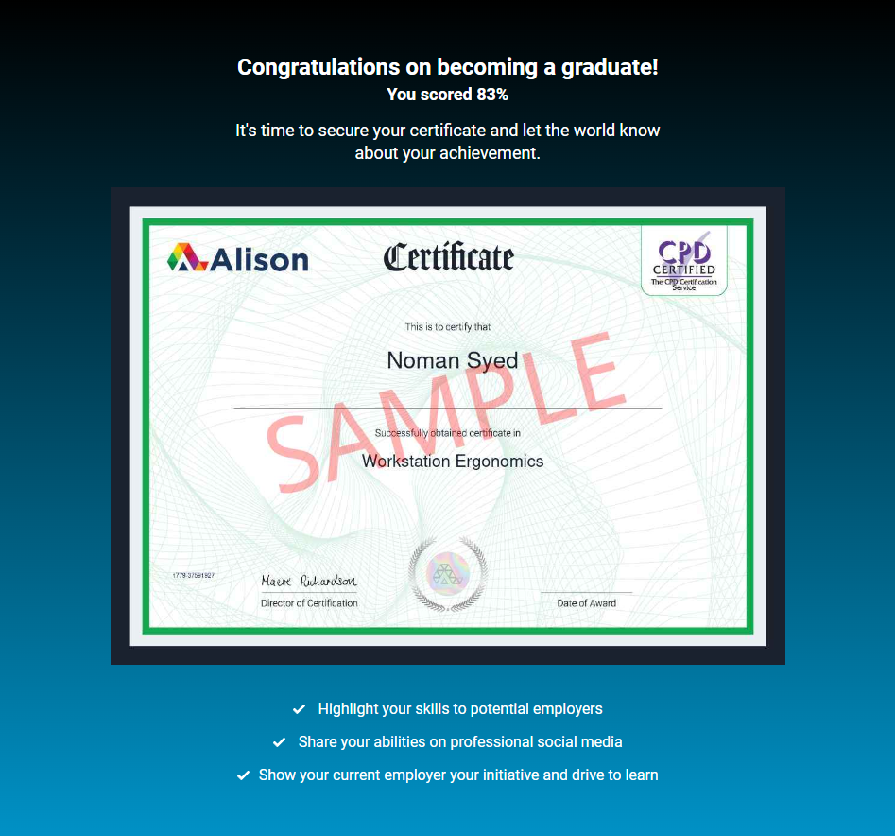

**Week 5**

* Revision

**Week 6**

- Review

**Week 7**

* Created Introduction
* Created Moodboards

**Week 8**

* Started the research (continued the introduction)
* Created the Persona Cards

**Week 9**

* Revision

**Week 10**

* Created the User Story & The Journey Map

**Week 11**

* Created the low & high fidelity wireframes

**Week 12**

* Started the Evaluation

**Week 13**

* Added last things

**Week 14**

* finished